
实验报告
( 2023-2024 学年 第 一 学期 )

课 程 | 高级语言程序设计
院（系） | 计算机科学与技术学院
专 业 | 人工智能
级 别 | 2023级
学 号 | 2325191003
姓 名 | 陈一鸣
指导老师 | 李海波

实验六

一、实验目的和要求：
(1)练习数组。

二、实验设备：
PC机、Visual C++6.0、Dev C++或Blocks

三、实验原理及内容
1. 字符串的查找和替换。例如原文：
char str[]=” East China Normal University is very beautiful. I like East China Normal University very much. There is a big playground in East China Normal University. The teachers in East China Normal University are very kind. The students are very polite and smart.”;
编程计算单词个数。

源程序代码如下（不要粘贴图片）：
#include<iostream>
#include<string.h>
using namespace std;
int main()
{
char str[] = " East China Normal University is very beautiful.I like East China Normal University very much.There is a big playground in East China Normal University.The teachers in East China Normal University are very kind.The students are very polite and smart,";
int num = 0;
char space = 32;
char period = 46;
for (int i = 0; i < strlen(str); i++)
{

if (str[i] == space) num++;
else {
if (str[i] == period)num++;
}
}
cout << num << endl;
return 0;
}

程序运行结果如下（粘贴截图）：
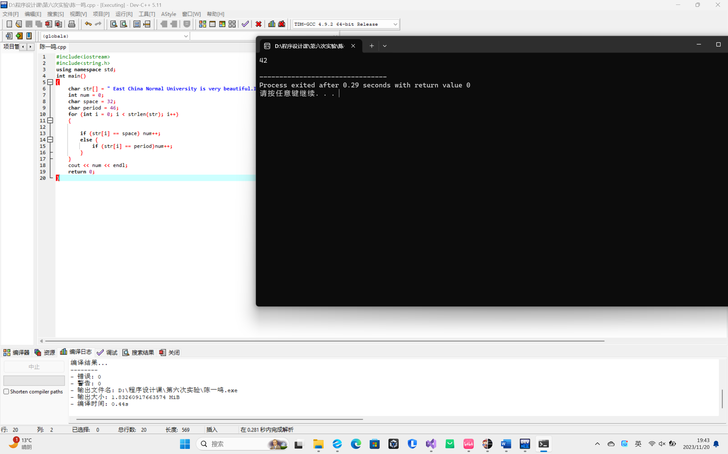

- 实验小结：
So easy!

